THE MILLANGIVM
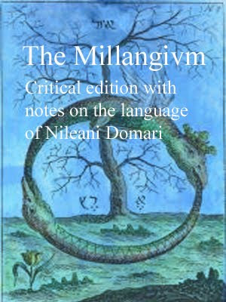
THE MILLANGIVM
CRITICAL EDITION WITH NOTES ON THE LANGUAGE OF NILEANI DOMARI
The Englewood Press, 2009, 734 pages

Aeon lúslí sdìdy agwet s'Nileani Domari lánslóaslà.
:::
A [niche, nice] study on the Nileani Domari language.

Ud gwèn anwnzáad s'gruk fdem www.zineb.webs.com (download raedd PDF)
:::
You can download the book from www.zineb.webs.com (download in PDF)
by Ayndryl on Tuesday, December 01, 2009
Labels Millangivm

